Pamplona National High School
Poblacion, Pamplona, Camarines Sur
Detailed lesson plan in Science 7

- General Objectives
- Describe the location of the Philippines with respect to the surrounding Landmasses and Bodies of water.

- Specific Objectives:
At the end of the one hour lesson, 75 % of the students must be able to:
- Identify the Landmasses and Bodies of water that surround the Philippines;
- Locate the landmasses and bodies of water that surrounds the Philippines using a globe/map; and
- Cite the importance of knowing the surrounding geography of an area in describing its location.

- Subject Matter
- Topic: Landmasses and Bodies of water
- References: Science 7 (Teachers and Students Manual) pp. 84-86
- Encarta Premium DVD 2009
- Encarta Dictionary
- Collins Dictionay
- Timeframe: 1 hour
- Materials: LCD Projector, Laptop, Activity Sheet, Chalk, Chalkboard, Cartolina, World Map
- Concepts:
- Philippines is surrounded by several Landmasses and Bodies of water
- Philippines is an Archipelago
- The location of the Philippines can be describe by identifying the Landmasses and Bodies of water that sounds it.
- Values Integration: Appreciation, Cooperation, Teamwork, Discipline, Time management
- Skills: Describing, Identifying, Locating
- Teaching Methodology: 4A’s Approach

- Learning Procedure
Time Frame | Teachers Hint | Teachers Activity | Students Activity | I.M
3mins. | - Preliminary Activity  - Greetings  - Opening Prayer  - Classroom Management  - Checking of Attendance  - Checking of Assignment  - Recall | Good morning Class!  Please stand for the Prayer.  Ramon, kindly lead the Prayer.  Before you take your seats, kindly pick up the pieces of paper and plastic in your vicinity and arrange your chairs properly.  Secretary of each group kindly monitor your group mates and check their attendance.  Class do we have an assignment?  Okay, exchange you notebook with your seatmates and let us check.  Class before we start with our lesson for today, who can give us a recap of our previous discussion? Yes, Ann.  Exactly! Do you still have questions regarding our previous lesson? | Good morning Ma’am!  (The students will stand and Pray)  (The students will pick up the pieces of paper and plastic in there vicinity and arrange the chairs properly.)  (The secretary of each group will check the attendance)  Yes, Ma’am.  (The students will exchange their notebooks with their seatmates and check)  Last meeting we discussed about the lines of latitude and longitude and locate places on Earth using the lines of latitude and longitude.  None ma’am.
5 mins | - Motivation | To start with our lesson for this morning I have something to show you.  (Posting an image of blank map on the board)  What can you see on the board?  Okay very good. What do you think is represented by the area in the map given the color green? Yes, John.  Exactly! How about the color blue? What does it represent? Yes, Jessan.  Correct. Now can you identify the landmasses and bodies of water found in the map? Yes, Eloisa.  Alright you have identified the Philippines from the map. Now, where in the map is the Philippines?  Yes, Ave.  How will you describe the location of the Philippines in the map?  Alright very good, But what if my question is, where in the world is the Philippines?  See, it is easy to tell where the Philippines is from the map. But, when I ask you, where in the world is the Philippines? You definitely cannot tell me where it is. | We see a blank map ma’am.  It represent the Landmasses ma’am.  It represent the Bodies of water ma’am.  (the students have varied answer)  (Ave will pin point the location of the Philippines from the map)  The Philippines is surrounded by water, Ma’am.  (The students are expected not to know how to answer the question) | Blank map
2 mins  2 mins | - Lesson Proper  - Presentation of the Lesson  - Presentation of Learning Objectives  - Unlocking of Difficulties | Class, what do you think is our lesson for today?  That’s right! We are going to discuss about landmasses and bodies of water that surrounds the Philippines.  To guide us as to what you should learn from our lesson this morning, let us be guided by the following learning objectives.  Now, who can read our leaning objectives? Yes, Melanie.  Class, let us help each other to achieve our learning objectives.  Class, we got a problem. We cannot proceed to our lesson unless you unlock the Encrypted words. These words are very important, because it will help us achieve our learning objectives.  Will you help me Decrypt the words class?  ENCRYPTED WORDS  - BSDIJQFMBHP  - DPOUJOFOU  - QFOJOTVMB  - HFPHSBQIZ  CONGRATULATIONS! Class, you were able to unlock the words. So, the words are. Please read Angel.  We can now proceed to our Activity. | It is about Landmasses and Bodies of water ma’am.  At the end of the one hour lesson, the student should be able to:  - Identify the Landmasses and Bodies of water that surrounds the Philippines;  - Locate the landmasses and bodies of water that surrounds the Philippines using a globe/map; and  - Cite the importance of knowing the surrounding geography of an area in describing its location.  Yes, ma’am.  (The students will decrypt the encrypted words.)  ARCHIPELAGO – is a group or chain of Islands  CONTINENT- is a very large area of land consist of several counties.  PENINSULA- is a long narrow piece of land which sticks out from a large piece of land and is almost completely surrounded by water.  GEOGRAPHY-is the study of Earths physical features. | Laptop, LCD Projector  Laptop, LCD Projector
5 mins  10mins.  2 mins | - Activity  - Pre-Activity  - Activity Proper  - Post Activity | Class the activity that you are going to perform today is entitled “Where in the World is the Philippines? (Part II)”. Why part 2? Because you have already located the Philippines in the world by using the Latitude and Longitude. These time, you are going to locate the Philippines in the world by identifying its surrounding geography. To do these, let us divide the class into 4 groups. The first 3 rows on my left will be the group 1, and the remaining rows will be the group 2. The group 3 will be the first 3 rows on my right, and the remaining rows will be the group 4.  Group 1 please stand and choose your leader. Next, Group 2, then Group 3 and finally Group 4.  Okay, you may now take you seats.  Now let us discuss the procedures and explain what you are going to do in the activity.  (Reading and explaining the procedures)  Are the procedures clear?  Group leaders please come to me and get you materials.  Class let us agree with the following Criteria/Rubrics on how you will be rated.  RUBRICS  Promptness 10%  Teamwork 10%  Presentation 30%  (Neatness and reporting)  Correctness of Entry 50%  100%  Okay, I will give you 5 minutes to do the activity.  Activity No. 2  Where in the world is the Philippines? (Pat II)  Objective  After performing this activity, you should be able to describe the location of the Philippines with respect to the surrounding landmasses and bodies of water.  What to use  Globe or world map  What to do  - Using a globe or a world map as reference, label the blank map below.  - You labelled map should include the following:  - Landmasses B. Bodies of Water  Philippine archipelago Philippine sea  Asian continent South China sea  Malay Peninsula Indian ocean  Indonesian archipelago Pacific ocean Australian continent  Guide Questions  Q1. Which bodies of water in the list are found on the west of the Philippines?  Q2. Which body of water in the list is located on the east of the Philippines?  Q3. Which large landmasses is found on the north of the Philippines?  - Be ready to show the map with your labels when your teacher asks you.  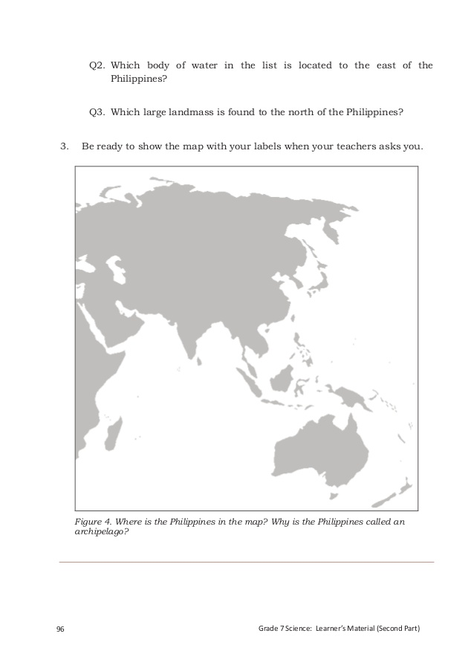  (After five minutes…..)  Class time is up. You may post your work on the board and be ready for the reporting. | (All members of Group 1 then 2, 3 and 4 will stand and choose their leader)  (The students are listening attentively)  Yes, ma’am!  (The leaders of each group will get the materials)  (The students are performing the activity)  (Each group will post their work on the board.) | Laptop, LCD Projector  Activity Sheet, Blank map, catolina, marker, map
8mins | - Analysis | How did you find the activity?  Why were you confused?  Alright, so what did you do to overcome it?  Excellent. So much for that let us now check your work.  (The teacher will check and evaluate the output of the students using the rubrics given prior to the activity.) | Its confusing Ma’am.  Because the given name of the Landmasses and Bodies of water from the activity sheet is not exactly the same as what is written on the map.  We’ve remembered the words that we unlock before the activity and with the help of our stock knowledge we identified that we are on the right track. | Marker or chalk
5mins | - Abstraction | Class, from the activity you have already identified the Landmasses and Bodies of water that surrounds the Philippines by locating it using a map.  Now, going back to my question earlier. Who can now describe the location of the Philippines with respect to the landmasses and Bodies of water that surrounds it?  Excellent!  Why is the Philippines called an archipelago?  Definitely! And what are the three biggest Island in the Philippines?  Exactly.  Class, do you still have question regarding our lesson for today? | The Philippines is located in the southern part of the Asian continent. It is surrounded by different bodies of water. To west of the Philippines found the south china sea and the Indian Ocean and to the east you can find the Philippine sea and the Pacific Ocean.  Because the Philippines is composed of group or chain of Islands.  They are the Luzon, Visayas and Mindanao.  None, Ma’am.
5 mins | - Application | Class, what is the importance of knowing the surrounding geography of an area in describing its location??  Indeed!  Congratulation Class, by now you can say that you really know were the Philippines is. You can now describe its location in two ways: by using latitude and longitude and by identifying the landmasses and bodies of water that surround it. | Knowing the surrounding geography of an area would help us easily describe its location and locate it.
3mins | - Generalization | Class, let us generalize our lesson this for morning.  What have you learned?  Excellent! | I’ve learned that aside from identifying the places on Earth using the lines of the latitude and longitude, we can also identify places on Earth by describing its location with respect to its surrounding geography.
5 mins.
- Evaluation

- Which of following is a way to describe the location of a place on Earth
- By using latitude and longitude
- By identifying the landmasses and bodies of water that surround it.
- A only
- Both A and B
- Which bodies of water is found to the west of the Philippines?
- Pacific Ocean
- West Philippine Sea
- South China Sea
- Indian Sea
- Which large landmasses is found to the north of the Philippines?
- Malay Peninsula
- Australian Continent
- Asian Continent
- Indonesian Archipelago
- Knowing the surrounding geography of a place will make you
- Find it difficult to locate the place
- Confuse of the location of the place
- Easily locate the place
- Nothing
- To locate places on Earth, what should you use?
- Telescope
- Philippine Map
- World Map
- Compass

2mins.
- Assignment
- How does our latitude position affect the water resources and biodiversity in the county?
- What are the factors that affect the amount of water in watershed?

- Reference
-Science 7 (Leaners Manual Pat 2) pg. 87-89

Prepared by:

Mary Grace Samilo-Cuadrante
Student Teacher

Noted: Approved:

Milagros N. Hernandez Imelda S. Del Rosario
Cooperating Teacher Principal II-PNHS

Marietta B. Terillano
Cooperating Teacher

