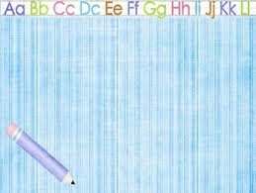**Narrative Report**

“A,B,C,D... letters to form words.

1,2,3… numbers to count.

Both have curves in shaping one’s life and learning.

Way back January 30 in this present year was the day that I started to spent my life dealing little learners until the end of our stay at Pamplona with the coordination of English department of Pamplona National High School. As expected, I am a secondary teacher but I want also to extend my learning’s and experiences in helping those dreamers at their early age.

Every Saturday at 2:00 to 4:00 in the afternoon was the time that we stepped the “Isla Noah” a place where the little dreamers lived. Reading, Storytelling, Spelling and Drawing were the things that we are developing to them.

Angelo, Franklin and Marvin were the learners assigned to me. With the same kind of the normal medium of instruction of learning, I saw the stages of learning they have. Angelo, has a very strong personality in terms of learning new things. He is very participative in the discussion when we are having the story telling, he is also good in spelling and reading. Second, Franklin is a kind of learner which I can classify in the average or middle type. He is also participative in the discussion, good in reading but there are some mispronounced words and he can also spell correct and incorrect words. My third student is Marvin, he is a timid type of a learner which you need to give more motivation in order for him to participate. He can read slightly, can spell words but most of the words are misspelled.

After several weeks past, all of them are improving and showing their interest to learn. Indeed, they are also showcasing their talents in drawing. This community service in Isla Noah at Poblacion, Pamplona, Camarines Sur gave me an unforgettable experience to see myself extending the things that I can do more than the limitation in teaching in PNHS.

And now…

I am confident that those learners that I handled for almost 2 months would not be only be a dreamer but somehow and someday they will become future leaders or successful man of this 21st century.

“Good Learners of Today, Future Leaders of Tomorrow”.

**VERONICA B. SUMAGPANG**

Student Teacher (English)

**Documentations**

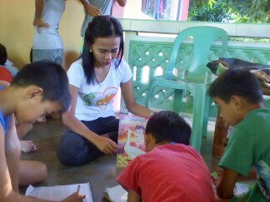**(Community service at ISLA NOAH)**

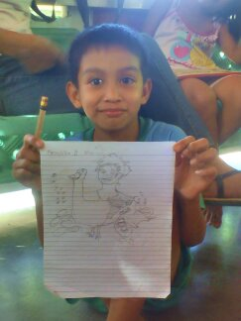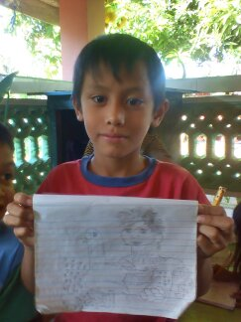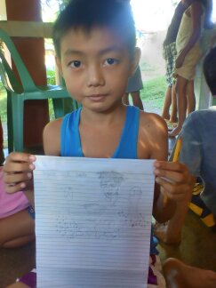

**MARVIN**

**FRANKLIN**

**ANGELO**